**Treasurer’s report to the May members’ meeting.**

**Income & Expenditure to April 2018**

Since the last members’ meeting the total offerings have picked up and are now cumulatively only 0.8% below budget (they were cumulatively 2.4% down in February). This is good news and it has brought the 12 month rolling average to an increase of 3.0% year on year.

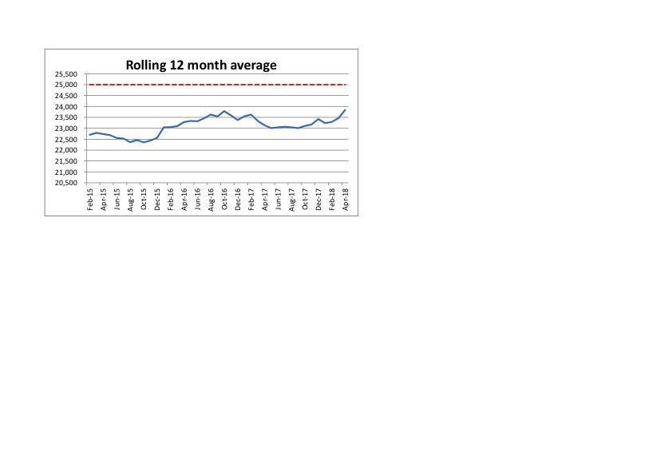

Expenditure is £7,000 over budget, which is mainly due to three large items of expenditure: -

1. Upgrading the sound and vision equipment in Sapphire and Emerald rooms.
2. The fitting of the new keypad, lock and intercom to the smaller entrance in West Way.
3. The decorating of the Main Hall and other areas.

Although these items were not specifically budgeted for in the “day to day” running costs, they were part of the schedule of works that we had highlighted at the end of last year to be funded from the legacy fund. You will recall from previous members’ meetings that we agreed that any “unrestricted” legacies that we receive, will be allocated to a legacy fund and that this fund will be used to meet any significant items of expenditure or ‘special’ missionary needs that arise in the future. The legacy fund started the year at £32,000 and is now down to £25,000.

We have recently received an update from the Baptist Union regarding the significant deficit in the Baptist Pension Scheme (Currently £93M as at 31/12/2016). Following lengthy negotiations the following outcomes were agreed :-

•  Very significant additional cash contributions (£33.5M) to the Scheme being made by the Baptist Union of Great Britain (BUGB)

•  No change to the monthly deficit contributions for RBC.

•  RBC’s additional deficit contributions are planned to finish in 2028 (original plan was 2035)

I believe that this is very positive news as we are dealing head on with the crisis now, rather than leave it to a future generation, and it improves the overall security of member benefits, while also reducing the long-term burden on the contributing churches.

Every Baptist church, that has a contributing member to the fund, is still facing a significant potential liability –the “employer debt”. Although the sums involved are extremely significant (RBC’s estimated employer debt at 30/04/18 is £412,100), we have to remember that this payment is only triggered if RBC ceases to have a minister who is a member of the pension fund. This is something that we do not envisage happening and we continue, along with all other Baptist churches, to contribute additional monthly amounts into the pension fund, as part of the BU’s plan to eradicate the deficit by 2028.

The accounts for 2017 are now with the auditors and will be presented to the church at the first Members’ meeting after they become available.

***The Lord continues to uphold us with His righteous right hand***

I look forward to seeing you all at the members’ meeting on the 30th March

**Craig Rowland**